Assessing Post-disaster Recovery to Inform Prediction of Economic Loss in Future Floods

Supplementary Information

S1. Implementation details of the pixel-level flood detection model

S1.1 Label generation and sample construction
The supervised learning task was formulated at the pixel-event level. Each sample represented the NTL temporal response of one candidate pixel around one flood event. Binary labels were assigned through interpretation of BEAST-smoothed recovery curves. A sample was labelled as affected when the curve showed a clear disruption pattern around the flood date, typically characterized by an abrupt decline in NTL intensity followed by gradual recovery. A sample was labelled as unaffected when the curve showed no evident event-related disruption or only normal temporal fluctuation. Ambiguous curves were excluded from the labelled dataset to reduce label uncertainty.
The labelled dataset contained 1,000 pixel-event samples, including 325 affected samples and 675 unaffected samples. These samples were selected from 18 flood events across 9 counties in 5 states. The sampling strategy was designed to include diverse disaster events, geographic contexts, and recovery patterns rather than relying on a single event or region.

S1.2 Input features and preprocessing
Each pixel-event sample included a daily NTL time-series window and a set of statistical descriptors. The time-series window covered 100 days before and 150 days after the flood event. Statistical descriptors were extracted from the NTL sequence using tsfresh with the EfficientFCParameters setting. These descriptors captured distributional, trend-related, and fluctuation-related properties of each pixel-level NTL trajectory.
Before model training, the raw NTL time-series input was normalized using row-wise z-score normalization. This transformation allowed the model to focus on relative temporal changes within each pixel rather than absolute brightness differences across locations. The tabular features extracted from tsfresh were standardized using a scaler fitted only on the training data and then applied to the validation and test subsets. Missing or invalid feature values generated during feature extraction were imputed before model fitting.

S1.3 Neural network architecture
The neural network component was designed to jointly learn sequential and tabular information. The temporal branch consisted of a one-dimensional convolutional layer, a max-pooling layer, a bidirectional LSTM layer, and dropout regularization. The tabular branch received standardized tsfresh descriptors and passed them through fully connected layers. The outputs of the temporal and tabular branches were concatenated and passed through additional dense layers, followed by a sigmoid output layer that estimated the probability of flood impact.
The neural network was trained using the Adam optimizer with a learning rate of 0.001, binary cross-entropy loss, a batch size of 32, and a maximum of 100 epochs. Early stopping was applied based on validation PR-AUC, and the best weights were restored after training. A learning-rate reduction strategy was also applied when validation PR-AUC stopped improving.

S1.4 Calibrated GBDT component
A calibrated gradient boosting classifier was trained as a complementary model to capture stable statistical patterns in the tabular features. The GBDT input combined the standardized tsfresh descriptors with six additional summary statistics calculated from the NTL sequence: mean, standard deviation, minimum, maximum, last observed value, and linear trend slope. The classifier was implemented using a histogram-based gradient boosting model and calibrated using isotonic probability calibration. This produced an independent calibrated probability estimate for each pixel-event sample.

S1.5 Class imbalance handling
Class imbalance was addressed using both resampling and weighting. In the neural-network training data, positive samples were oversampled to three times their original size through random sampling with replacement. Balanced class weights were then computed from the training labels and used during model fitting. For the GBDT component, sample weights were computed inversely proportional to class frequency, and the positive-class weight was further multiplied by 1.15. This combination was used to reduce the dominance of the majority unaffected class while maintaining sensitivity to flood-affected pixels.

S1.6 Probability fusion and cascade decision rule
The neural network and calibrated GBDT produced two probability estimates for each pixel-event sample. These were fused using weighted probability integration:
$$p_{blend}=\left(1-w\right)p_{NN}+wp_{GBDT}$$ | (Eq. S1)
where $p_{NN}$ and $p_{GBDT}$ denote the probabilities estimated by the neural network and GBDT classifier, respectively. In the final model, $w=0.5$. A cascade rule was then applied. Samples with $p_{GBDT}$ below a low screening threshold were classified as unaffected. For the remaining samples, the final prediction was determined by comparing $p_{blend}$ with the final classification threshold. Both thresholds were selected on the validation set through grid search.

S1.7 Data splitting and leakage assessment
The primary reported model performance was based on a stratified pixel-event-level split. First, 30% of the labelled samples were reserved as the test set. Then, 20% of the remaining training samples were used as the validation set. Stratification preserved the class ratio across training, validation, and test subsets.
Because pixel-event samples from the same flood event or nearby pixels may share similar temporal and spatial characteristics, a random pixel-event split may not fully eliminate event-level or spatial dependence. To address this concern, an additional event-level held-out validation was conducted. In this stricter validation, all samples from selected flood events were excluded from training and used only for testing. This validation included 5 events and 300 pixel-event samples, and the model achieved an accuracy of 87.0%, with 79.8% precision, 80.6% recall, and an F1-score of 80.2% for affected pixels.

S2. Robustness checks for the counterfactual GAM baseline
To verify that the loss anomaly reported in Section 3.1 is not driven by the specific 12-month independence threshold or by misspecification of the baseline model, we performed three diagnostic checks.

S2.1 Sensitivity to the independence threshold
We re-estimated the entire counterfactual GAM pipeline at three alternative independence thresholds (9, 15, and 18 months), following the identical event-sequencing rule and model specification as the published 12-month version. Deviance explained is stable across thresholds (9 months=53.6%, 12 months=56.6%, 15 months=53.8%, 18 months=53.4%). On the 238 counties common to all four thresholds, the Spearman rank correlation of the county-level log-anomaly is 0.93 (9 vs 12 months), 0.91 (12 vs 15 months), and 0.89 (12 vs 18 months). Figure S1 shows how the counties classified as Vulnerable, Neutral, or Resilient at 12 months redistribute under the three alternative thresholds: 96%/89%/87% of Vulnerable counties at 12 months remain Vulnerable at 9, 15, and 18 months, respectively; the corresponding retention rates for Resilient counties are 80%/90%/90%. Only 3 (9 months), 8 (15 months), and 9 (18 months) of 238 counties undergo a full Vulnerable–Resilient reversal. The spatial pattern of loss amplification and resilience is therefore essentially preserved under reasonable variations of the independence threshold and is not an artifact of the specific 12-month choice.
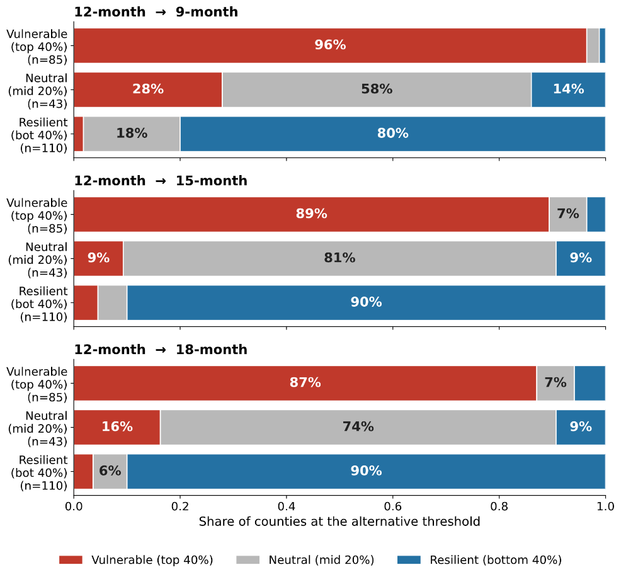
Figure S1. Sensitivity to the independence threshold
Robustness of the county-level loss-anomaly classification to the independence threshold used to define independent flood events. Each row corresponds to one of three bands defined under the published 12-month threshold (Vulnerable=top 40th percentile of county log-anomaly; Neutral=middle 20%; Resilient=bottom 40th percentile); each bar shows how those counties are reclassified when the independence threshold is changed to 9 months, 15 months, or 18 months. Bars dominated by their own colour indicate that counties retain their classification across thresholds. Analysis is restricted to the n=238 counties present under all four thresholds.

S2.2 Out-of-sample predictive performance
To verify that the baseline model is not overfit to the training events, we performed 5-fold cross-validation on the 12-month independent-event training set. The out-of-sample Pearson correlation between predicted and observed log losses was r=0.549 (RMSE_log=2.94; MAE_log=2.34). Given that the response variable spans more than four orders of magnitude (NifpLoss ranges from≈$10² to $10⁹), this level of held-out agreement indicates that the baseline captures a substantial and stable component of the systematic loss signal.

S2.3 Residual diagnostics
All five smooth terms in the GAM have adequate basis dimensions according to mgcv's k.check procedure, with p-values ranging from 0.24 to 0.77 (Table S1); none falls below 0.05, indicating no evidence of under-parameterized smooths.
Table S1. K.check results for the five smooth terms in the 12-month GAM
Smooth term | k′ | edf | k-index | p-value
s(resPenetrationRate) | 9 | 6.20 | 0.71 | 0.24
s(Income) | 9 | 1.00 | 0.72 | 0.37
s(NewBuild) | 9 | 1.63 | 0.72 | 0.30
s(areaRain) | 9 | 3.77 | 0.72 | 0.37
s(fctImp) | 9 | 4.81 | 0.74 | 0.77

S3. Sensitivity Analysis of Alternative Inter-Event Interval Thresholds
To evaluate the robustness of the interaction effect between prior recovery level and inter-event interval, we sequentially tested a series of alternative thresholds at both ends of the interval distribution (Table S2). This procedure allowed us to progressively identify the effective temporal range of the compound effect from both the lower and upper boundaries.
- At the upper bound, we examined progressively longer interval definitions (>9, >10, >11, and >12 months). The interaction term remained significant for the >9-month grouping (coef.=−0.522, p=0.005), but became consistently insignificant once the threshold exceeded 10 months (>10: p=0.165; >11: p=0.347; >12: p=0.917). This suggests that when the interval between two flood events exceeds approximately 10 months, the recovery state from the prior event no longer shows a statistically detectable association with subsequent losses, indicating that the events increasingly behave as independent shocks. These results therefore identify the stable upper boundary of the temporal compound effect.
- At the lower bound, when the analysis focused on extremely short intervals (≤3 and ≤4 months), the interaction term consistently reversed sign and became positive (≤3: coef.=0.112, p=0.048; ≤4: coef. =0.118, p=0.042). This indicates that under extremely short recovery intervals, higher prior recovery levels were associated with greater subsequent losses, consistent with a “secondary shock before recovery consolidation” mechanism, in which recovery resources remain insufficiently stabilized before the next disaster occurs. However, once the interval exceeded 4 months, the interaction term became stably negative and statistically significant (coef.=−0.46 to −0.55, p<0.01). This sign reversal therefore identifies the approximate lower boundary of the effect.
Taken together, the lower boundary (~4 months, where the coefficient shifts from positive to negative) and the upper boundary (~10 months, where the interaction effect disappears) jointly delimit the empirically stable 4-9 month interval, within which higher prior recovery levels are consistently associated with lower subsequent losses.
Table S2. Sensitivity analysis across interval thresholds
Threshold | N | Coefficient | SE | p | 95% CI
≤3 | 148 | 0.112 | 0.057 | 0.048 | [0.001, 0.223]
≤4 | 182 | 0.118 | 0.058 | 0.042 | [0.004, 0.232]
>4 | 703 | −0.460 | 0.175 | 0.009 | [-0.803, -0.117]
>5 | 669 | −0.547 | 0.181 | 0.003 | [−0.902, −0.191]
>8 | 602 | −0.509 | 0.189 | 0.007 | [−0.878, −0.139]
>9 | 574 | −0.522 | 0.187 | 0.005 | [−0.890, −0.155]
>10 | 543 | −0.267 | 0.192 | 0.165 | [-0.644, 0.110]
>11 | 512 | −0.191 | 0.203 | 0.347 | [-0.588, 0.206]
>12 | 461 | −0.023 | 0.216 | 0.917 | [-0.446, 0.401]

S4. Sensitivity Analysis of Recovery-Level Definition
To examine whether the main SEM results were sensitive to the specific definition of post-disaster recovery, we conducted additional sensitivity checks by varying the pixel-level recovery threshold and the stability rule used to classify affected pixels as recovered. In the main specification, a pixel was considered recovered when its post-disaster NTL radiance returned to at least 90% of its pre-disaster baseline and satisfied a 6-of-7 stability rule. To test the robustness of this choice, we recalculated the county-level recovery level using alternative thresholds and window rules, including a lower recovery threshold of 85%, a stricter threshold of 95%, and alternative k-of-7 stability rules.
The sensitivity results are reported in Table S3. Across all tested specifications, the interaction coefficient between antecedent recovery level and the critical disaster interval remained negative and statistically significant. The estimated interaction coefficients ranged from -0.36 to -0.55, with p-values ranging from 0.006 to 0.044. This indicates that the negative association between antecedent recovery and subsequent flood losses during the critical interval was not driven by a single recovery threshold or a specific k-of-n stability rule. Even under the stricter 95% recovery threshold, the interaction term remained negative and statistically significant, although the magnitude was slightly smaller. These findings support the robustness of the recovery-level measure used in the main analysis.
Table S3. Sensitivity of the SEM results to alternative recovery-level definitions
Recovery threshold | Stability rule | Interaction coefficient | p-value | Std. Err.
0.9 | 6-of-7 | -0.55 | 0.008 | 0.181
0.85 | 6-of-7 | -0.50 | 0.009 | 0.189
0.9 | 5-of-7 | -0.55 | 0.008 | 0.181
0.9 | 7-of-7 | -0.50 | 0.006 | 0.181
0.95 | 6-of-7 | -0.36 | 0.044 | 0.179
Note. The recovery threshold indicates the proportion of the pre-disaster NTL baseline that an affected pixel needed to reach in order to be classified as recovered. The stability rule indicates the number of valid observations within a seven-day moving window that were required to meet the recovery threshold. The interaction coefficient refers to the SEM path linking the interaction between antecedent recovery level and the critical disaster interval to subsequent flood loss. Negative coefficients indicate that higher antecedent recovery levels are associated with lower subsequent losses during the critical interval.

